**inSight 2017**

**Department : Computer Science department**

**Problem Title : Automated schedule tracker**

**Problem Code : PS05**

**Problem Description :**

The students meet the faculties every now and then and there is a high probability that they have to wait for the faculty since he/she is not free at that particular time. In order to avoid this application should be built in such a way that all the faculties or the people in the office (admin/main office) update their schedule. The calendar will be designed in such a way that it will reflect the timings when faculties are available and hence avoid the waiting time. Depending on the faculties free slot, the students may request a meeting. The meeting should be scheduled only if the faculty confirms .This application will be useful any official (including the principal) in the department. This should keep both student and faculties informed about all the schedules that they need.

**Proposed solution:**

**For the faculty members:**

* An interface in the structure of a time table will be provided. Faculties can mark the slots in which they have classes or are busy.

**#The free slots from above time table are stored in a database for that respective faculty for respective days to be provided to students.**

* Another panel(only for faculties) for confirming the meetings requested by students. With the student’s name, USN, time of visit and purpose of meeting, it will provide two options (confirm and decline) to the faculties.

**#The replies of the faculty members are returned back to the students to inform them.**

**For the students:**

* Login page which redirects them to Meeting scheduler page.
* This page tells the students if their previous requests have been confirmed or declined and the second portion allows them to place a request.
* Student chooses the Dept. of the faculty member which shows the names of the respective branch faculties(dropdown). After selecting the name, they get the next dropdown for selecting the day.
* After selecting the day, comes up the free slots of that faculty for that day.
* After choosing that slot, they are provided with a text box to write the purpose of their meeting.
* They get a button for “Request For Meeting” to place a request.

**#The request is placed by sending the name, USN, Purpose of meet.**

**Technology Stack :**

**Languages:**

* PHP
* HTML
* CSS
* JavaScript

**Use Case:**

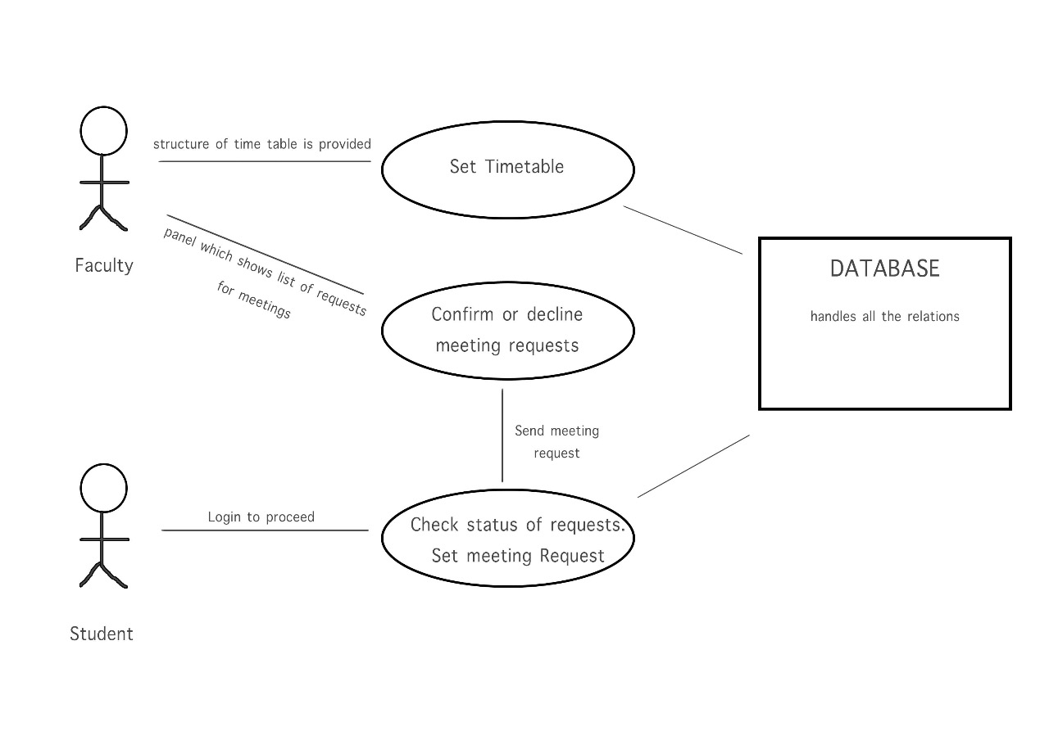

**Team Members details:**

|  |  |  |  |  |
| --- | --- | --- | --- | --- |
| **Role** | **Name** | **USN** | **Email id** | **Phone no.** |
| Team Leader | Mitesh | 1SI15CS059 | mitesh.vishwakarma@gmail.com | 9738160729 |
| Team Member 1 | Aayush Ranjan | 1SI15IS067 | aayush.ranjan15@gmail.com | 9868338099 |
| Team Member 2 | Mitesh Vishwakarma | 1S15CS059 | mitesh.vishwakarma@gmail.com | 9738160729 |